14.84: a) Using the constancy of angular momentum, the product of the radius and speed is constant, so the speed at the rim is about 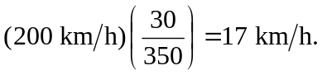 b) The pressure is lower at the eye, by an amount
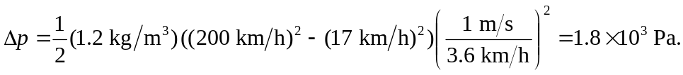
c) 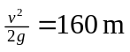to two figures. d) The pressure at higher altitudes is even lower.

